Stock Market Live Data

Architect Diagram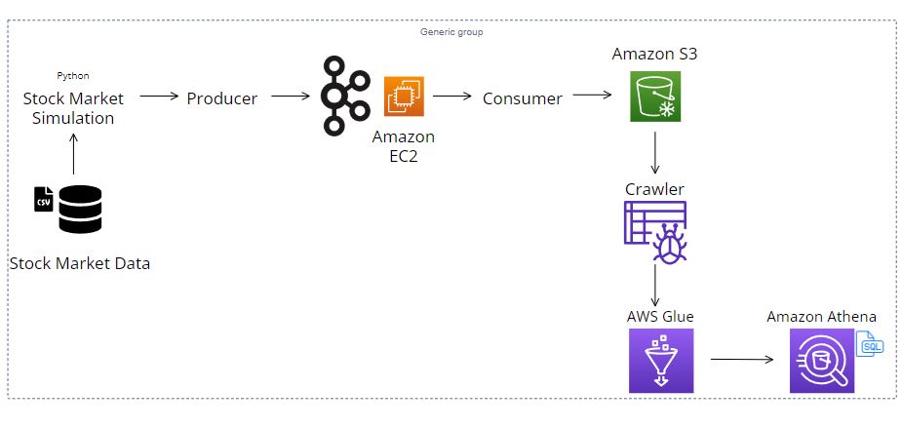

The CSV files to simulate the real time stock market system

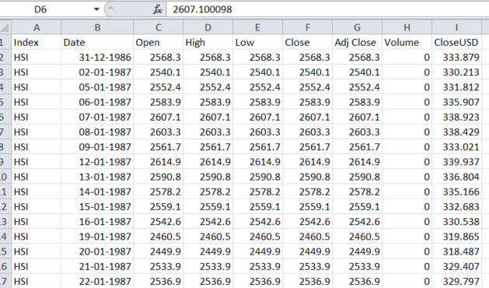

The Kafka Producer and Consumer Code is available in the GIT HUB. Import the same in Notebook.

Create your AWS Free account for the hands-on.

AWS S3 Bucket

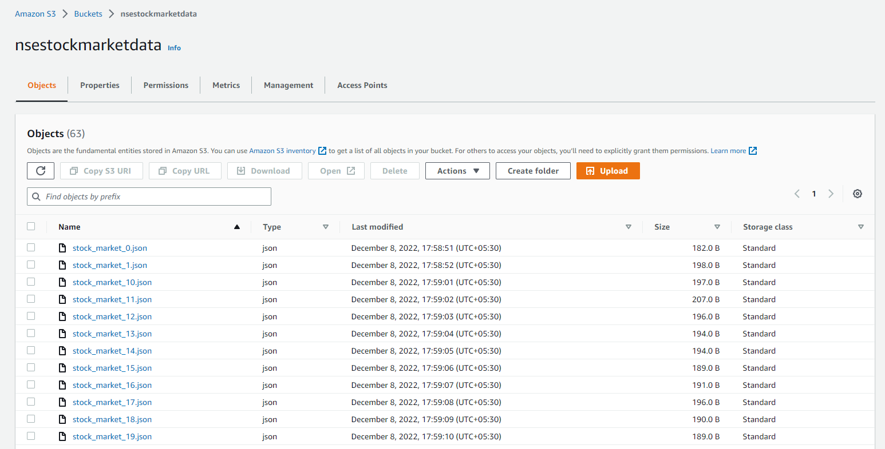

AWS Glue Crawlers

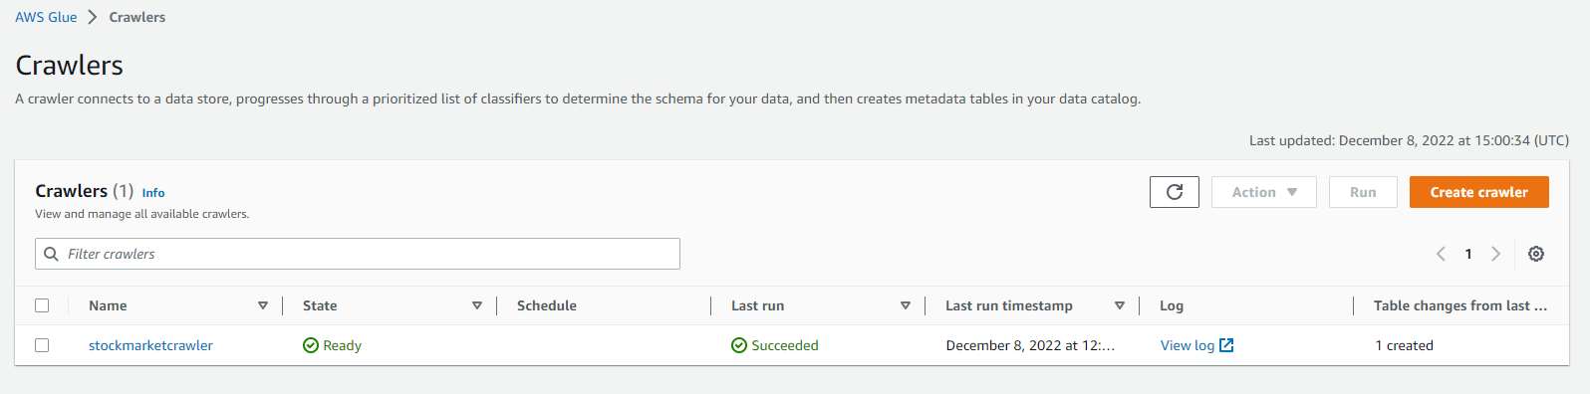

AWS Athena

